Access Request - Annual Recertification
V2.0 10-19-18

Annual Recertification is a simple process that is required by security regulations for each role a user has in an application. If you fail to request recertification for a role you are using and/or your supervisor does not approve in a timely manner, your access will be cancelled and you will have to re-apply for access.

Recertification Overview
- Sign into EARS
- Check and update your User Profile for your current supervisor (if necessary)
- Request to be recertified for each role you continue to need or cancel the ones you no longer need.
- Your supervisor approves the roles you request (assuming they are still needed)
That’s All you need to do !!
See Below for Detailed Steps

Recertification Detail

- The User will sign into EARS using their ENT or GSA network (EXT) login credentials via https://ears.ocfo.gsa.gov/ears/faces/home.jsp. Refer to the EARS User Guide (EARS Web Page Login), located in the Help/FAQ menu tab, for assistance with the login screen.
- Click on the Profile Update tab –** Please verify the Manager listed is your current manager, this is the person used to verify your access to the system/application is still required/authorized **
  - If the Supervisor/COTR is correct - Skip to Step 3
  - If the Supervisor/COTR is NOT Correct - Use Pull-Down to see if your manager is on the existing list of managers and choose him/her and go to Step 2.4
  - If your manager’s name is not displayed in the Manager/COTR drop-down menu, please contact EARS.Support@gsa.gov and request that they be added.
Do not proceed with submitting your request until you are notified by the EARS Service Desk that your manager has been added to the drop-down menu.
Then restart at Step 2.1
  - Go to the bottom of the form and click "Submit" button
  - Wait for a message of "Submission Successful" OR take a screen shot of any error message and send to ears.support@gsa.gov and then log out, as your manager change was not successful

- Once the User Profile has been checked/updated, the User will click the Access Request menu tab to perform the Recertification request. The access request queue will display all requests that require your action. If more than 10 records exist, you can use the arrow keys to maneuver between pages.
- Click on the access request you wish to request recertification for or to cancel; this will display the access request and highlight the populated request in the request queue in yellow
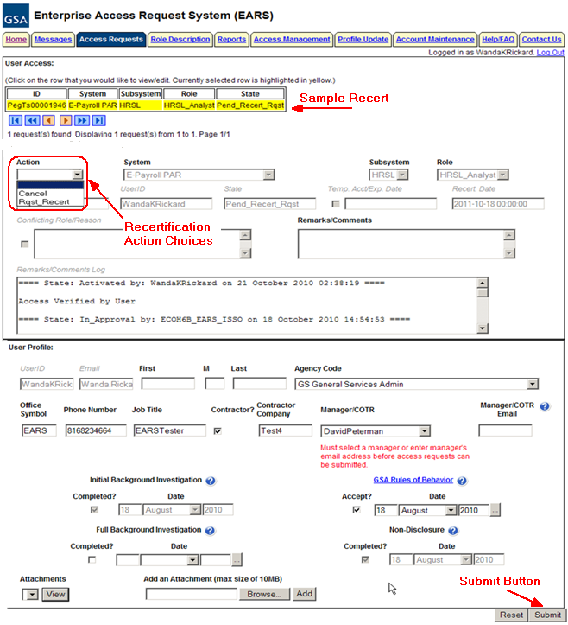

- Additional Fields to complete in User Access section (* denotes Required field) – Fields that are grayed out are unavailable. The fields listed below are the ONLY fields that are to be processed by the ‘User’
  - Action* – The User can Request Recertification (Rqst_Recert) or Cancel by clicking the down arrow Action button and choosing the appropriate action.
    - Rqst_Recert – This action will forward the recertification request to the specified manager, identified in the User Profile section of the access request.
    - Cancel – This action will forward the cancellation request directly to the Implementation Group.
  - Remarks/Comments – You may enter remarks/comments in this field, it will remain in your access record and be displayed to all managers throughout the approval process. If Cancel action is selected, this field becomes a required field.
- GSA Rules of Behavior – You must have a check mark and a date in the Rules of Behavior less than one year old. If this is not done your request will be rejected. If you need to review the link and review them and then enter today’s date.
- Reset Button – Clears the screen and allows for reentry
- Submit Button – Click the Submit button to start the Recertification process.
  - Upon clicking the Submit button a Confirmation Statement will appear.
  - The User must “… agree to protect the confidentiality of their password, ensure the UserID will be used only for official business and to exercise proper care to protect all system assets while performing their duties” by clicking OK.
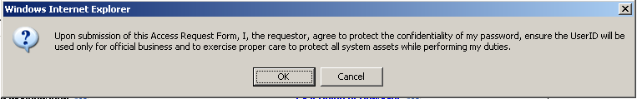
  - Upon submission a status message will appear at top or bottom of the page if the request was updated successfully. (Similar to below). This will complete the recertification process for a period of time (normally a year).
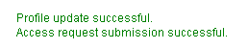
- For future reference next year’s request for recertification should occur, thirty days out from the recertification date, the user will receive an email from “ESC_Do_Not_Reply@gsa.gov” stating it is time to recertify the specified role(s). Additional email notifications will be sent at two weeks prior and one week prior if the access request has not been recertified.
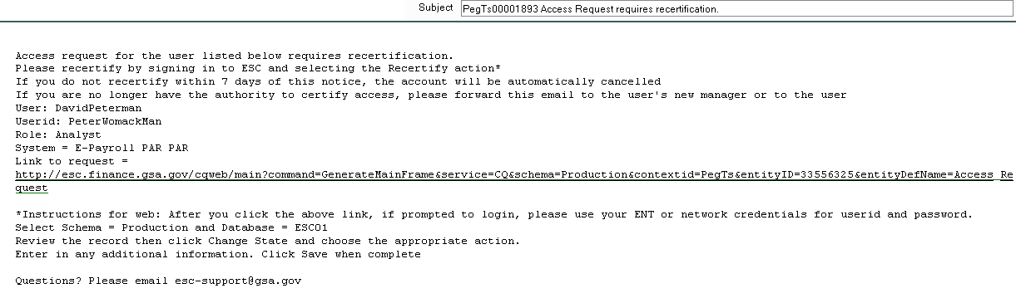
- If no further action is required by the User, select Logout, located in the upper right hand corner of the screen.

