New Access Request – User
V1.1 7-19-11

Requests for access to applications administered by EARS must be made for each “Role” that the requestor and his/her supervisor has agreed is needed to perform their assigned duties. The granting of access by role is a multi-step approval process dictated by security rules in effect in the agency.

Overview – New Access Request Process Steps for Applications
- Sign into EARS
- Check and update your User Profile for your current supervisor (if necessary)
- Select the System and Sub-System (Application) you need access to
- Choose the Role required to do your assigned duties (the specific role needed generally comes from your supervisor)
- Submit the Access Request
That’s all you need to do !!

See below for Detailed Steps for Requesting Access

Detail – New Access Requests

- The User will sign into EARS using their ENT or GSA network (EXT) login credentials via https://ears.ocfo.gsa.gov/ears/faces/home.jsp. Refer to the EARS User Guide (EARS Web Page Login), located in the Help/FAQ menu tab, for assistance with the login screen.
- Click on the Profile Update tab –** Please verify the Manager listed is your current manager, this is the person used to verify your access to the system/application **
  - If the Supervisor/COTR is correct - Skip to Step 3
  - If the Supervisor/COTR is NOT Correct - Use Pull-Down to see if your manager is on the existing list of managers and choose him/her and go to Step 2.5
  - If manager is NOT on the list, then scroll to the TOP of the choices where there is a BLANK line and choose the BLANK line
  - Next, enter the Email Address of the your immediate manager (ex john.doe@gsa.gov) who will approve the request
  - Go to the bottom of the form and click "Submit" button
Wait for a message of "Submission Successful" OR take a screen shot of any error message and send to ears.support@gsa.gov and then log out, as your manager change was not successful
- Once the User Profile has been checked/updated, the User will click the Access Request menu tab to perform the New Access request. The first part of a sample new access request is shown below. The step following goes into greater detail on the individual fields requirements..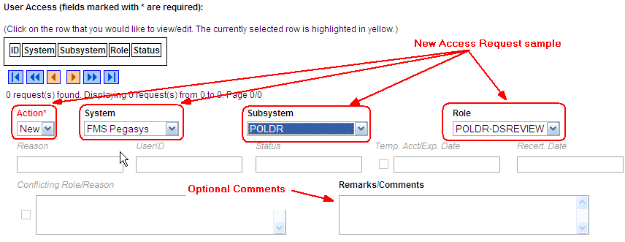

- User Access Section (* denotes Required field) – Fields that are grayed out are unavailable. The fields listed below are the ONLY fields that are to be processed by the ‘User’.
  - Action* – Click the down arrow button and select ‘NEW’
  - System*– Click the down arrow button to select the System to which you are requesting access.
  - Subsystem* – Click the down arrow button to select the Subsystem to which you are requesting access.
  - Role – (Although Role is not mandatory, processing will be quicker to choose the specific role needed. Maybe finding the specific role you need from your supervisor or co-worker with similar duties) click the down button to select the specific role needed or let it default to ** TBD ** role.
  - Remarks/Comments – You may enter remarks/comments in this field, it will remain in your access record and be displayed to all managers throughout the approval process.

- User Profile Section
  - Employee Name – First Name, Middle Initial (if applicable), and Last Name
  - Agency Code – Click the down arrow button to select your employing Agency
  - Office Symbol – Optional text field to allow entry of your Office Symbol
  - Phone Number – Enter 10 digit phone number
  - Job Title – Optional text field to allow entry of your Job Title
  - Contractor - Checkmark the Contractor box if applicable - This will require the user to acknowledge that a signed Non-Disclosure Agreement (NDA) is on file with the GSA contractor.
  - Contractor Company – Optional text field to enter the Contractor Company with which you are employed.
  - Manager/COTR * - Select Manager from drop down menu. If your manager is not displayed, then enter your Manager/COTR email address in the next field.
  - Manager/COTR email - If your manager’s name is not displayed in the Manager/COTR drop down menu, then enter your manager’s email address. ** This access request will be sent to the email address provided (for approval), so please double-check the email address before submitting. **
  - User Security Verification
    - Initial Background Investigation * – Required to submit an access request. If received, check the Completed box and enter the Date completed. This is required only once per UserID.
    - Full Background Investigation – Optional field. If user has received a full background investigation, check the Completed box and enter the Date completed.
    - GSA Rules of Behavior * – Required to submit an access request (also required to be reviewed on an annual basis). The link will direct you to the current GSA Rules of Behavior; once reviewed, check the Accept button as acknowledgement that you agree to adhere to the rules of behavior. Enter the Date reviewed or completed.
    - Non-Disclosure – If you checked the Contractor box, this becomes a required field. Check the Completed box and enter the Date completed which signifies that you have reviewed/signed the NDA and given to your COTR.
    - Attachments – The first attachment box allows the user to ‘view’ existing attachments. The second box allows the user to ‘add’ an attachment (i.e. email of background investigation for audit support)
- Reset Button – Clears the screen and allows for reentry
- Submit Button – Click the Submit button to begin the access request process.
  - Upon clicking the Submit button, a Confidentiality Statement will appear.
  - The User must “…agree to protect the confidentiality of their password, ensure the UserID will be used only for official business and to exercise proper care to protect all system assets while performing their duties.” by clicking OK before the access will be submitted
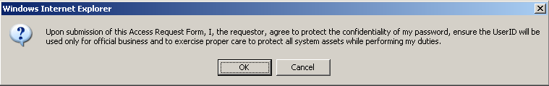
- Submitting the access request does not grant immediate access, it simply verifies the request has been transmitted from EARS into the ESC system and will be forwarded to the next level in the approval workflow process.
  - The bottom left or upper left of the page will display if the User Profile was updated successfully and/or the Access Request was submitted successfully.
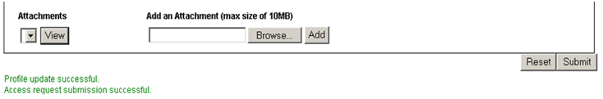

  - The newly submitted request will appear in the Request Queue, showing a state of Manager_Approval, meaning it has been forwarded to the specified manager for approval.
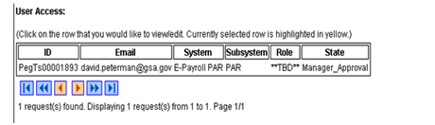

- If no further action is required, select Logout, located in the upper right hand corner of the screen.

