Access Request - Cancellation

- User Request to “CANCEL” an access request
  - The User can request to “CANCEL” an access request via the EARS application.
  - The User will sign into EARS using their ENT or GSA network (EXT) login credentials via https://ears.ocfo.gsa.gov/ears/faces/home.jsp.
  - Once logged in, the User will click the Access Request menu tab to perform the Recertification request. The access request queue will display all requests that require your action. If more than 10 records exist, you can use the arrow keys to maneuver between pages.
  - 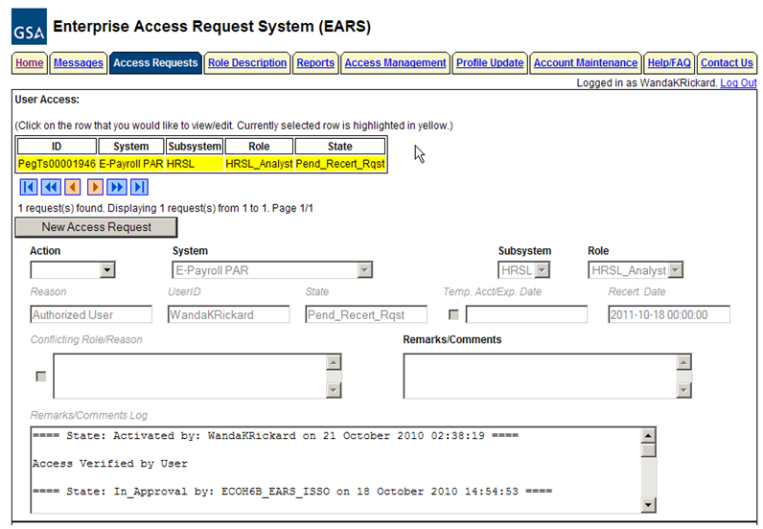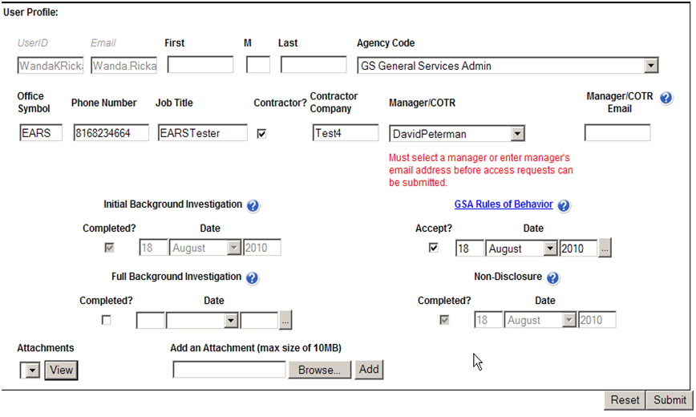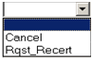Click on the access request you wish to verify; this will display the access request and highlight the populated request in the request queue.

  - User Access Section (* denotes Required field) – Fields that are grayed out are unavailable. The fields listed below are the ONLY fields that are to be processed by the ‘User’
    - Action* – The User can Cancel by clicking the down arrow Action button and choosing the appropriate action.
      - Cancel – This action will forward the cancellation request directly to the Implementation group.
    - Remarks/Comments – You may enter remarks/comments in this field, it will remain in your access record and be displayed to all managers throughout the approval process. If Cancel action is selected, this field becomes a required field.
  - User Profile Section – All fields can be modified (with the exception of the UserID, Email, Initial Background Investigation, and Non-Disclosure)
  - Reset Button – Clears the screen and allows for reentry
  - Submit Button – Click the Submit button to start the Cancellation process.
    - Upon clicking the Submit button a Confirmation Statement will appear.
    - The User must “… agree to protect the confidentiality of their password, ensure the UserID will be used only for official business and to exercise proper care to protect all system assets while performing their duties” by clicking OK, will complete the access request process and Activate the account.
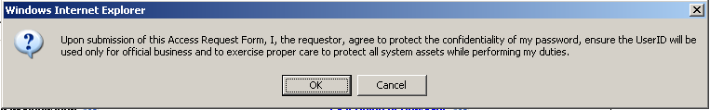
    - Bottom of the page will display if the Profile was updated successfully and/or the access request was submitted successfully.
  - If no further action is required by the User, select Logout, located in the upper right hand corner of the screen.

- Manager, Liaison, System Owner, or ISSO Request to “CANCEL” an access request
  - The Manager, System Owner, or ISSO will sign into ESC using their ENT windows network username/password combination … http://esc.finance.gsa.gov/cqweb/login
  - Perform a search for the appropriate employee and access record within the selected Database.
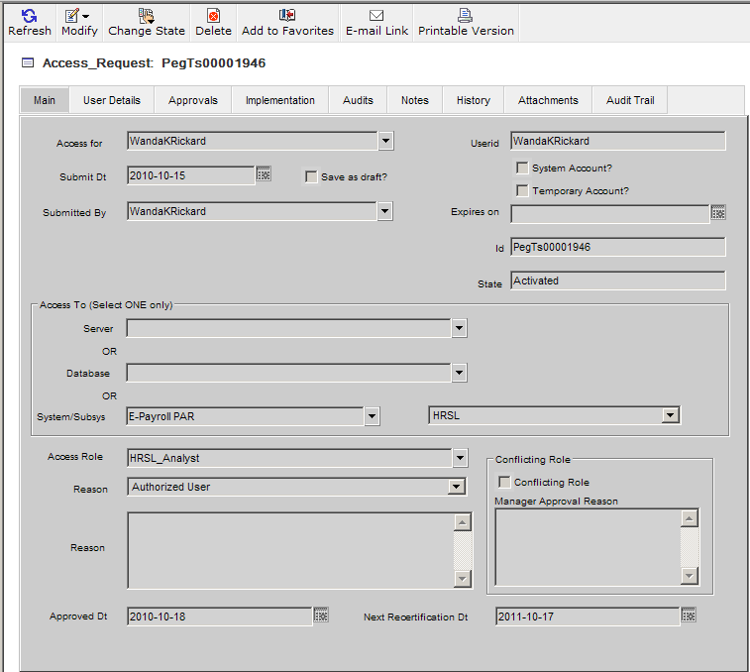
    - Once the employee record is displayed, the manager, system owner, or ISSO will click on Change State, and then select ‘Cancel’. Notes are required to be added as to why the account is being cancelled.
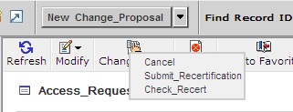
    - The Manager, Liaison, System Owner, or ISSO must ‘Save’ the record to start the cancellation process.
    - Once the cancellation record has been saved the action request is forwarded directly to the Implementation Group for access removal. Once the access is removed, an email is generated to the manager to verify the cancellation. The employee will never receive direct communication that the account was cancelled.

