Special Processing for External (Non-GSA) Users
- Since the OCIO EXT registration page is currently still under development, a workaround has been developed to handle the processing for External (Non-GSA) users, which is similar to how they are currently handled.
- The User will access the interim EXT registration page via the EARS home page https://ears.ocfo.gsa.gov/ears/faces/home.jsp.

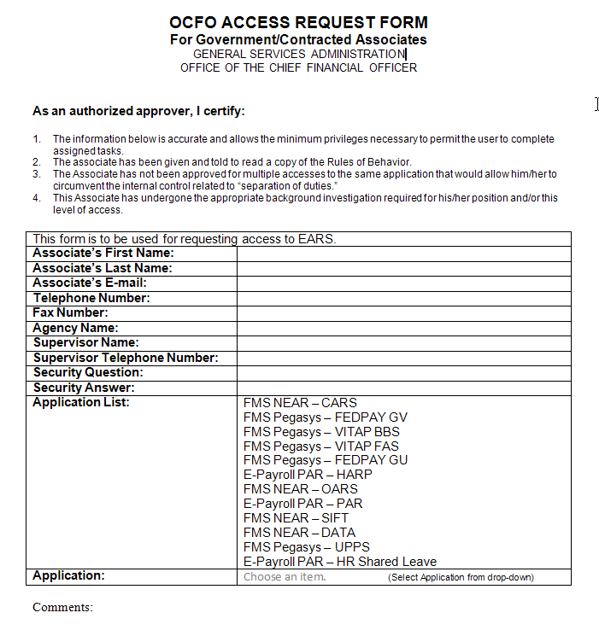

- After completing the OCFO Access Request Form, save as an Attachment and email to the corresponsding System/Subsystem Liaison.
  - If unsure of the System/Subsystem Liaison, refer to the Contact Us Menu Tab
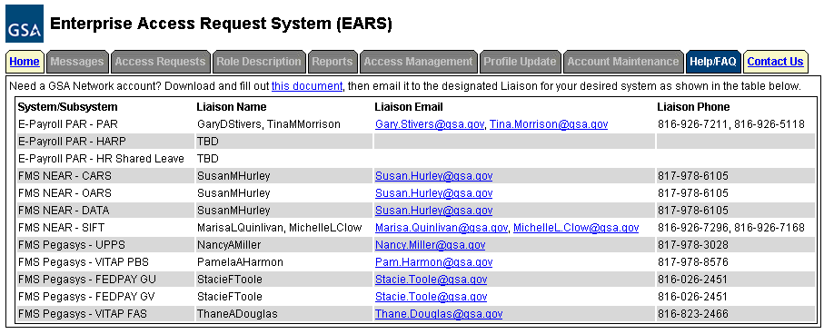

- The Specified Liaison will be required to enter a New Access Request via ClearQuest Web Client
- Before the Liaison enters a NEW access on behalf of the External User, the following is required:
  - The employee must forward an email requesting access to the system to their ‘actual’ manager.
  - The ‘actual’ manager will either approve or deny the request and that email chain will be forwarded to the Liaison as supporting documentation to the action required.
  - The Liaison must open the email and save it in a Microsoft Office Document Image Writer. To do this in Lotus Notes (Example Below)
    - Select File Print
    - Change the Printer Name to Microsoft Office Document Image Writer (The reason for this is to ensure the integrity of the data captured and placed in the ESC system as supporting documentation. Once saved, this cannot be changed – it is a read only access)
    - Click the Ok button (This will bring up a Save As box)
    - 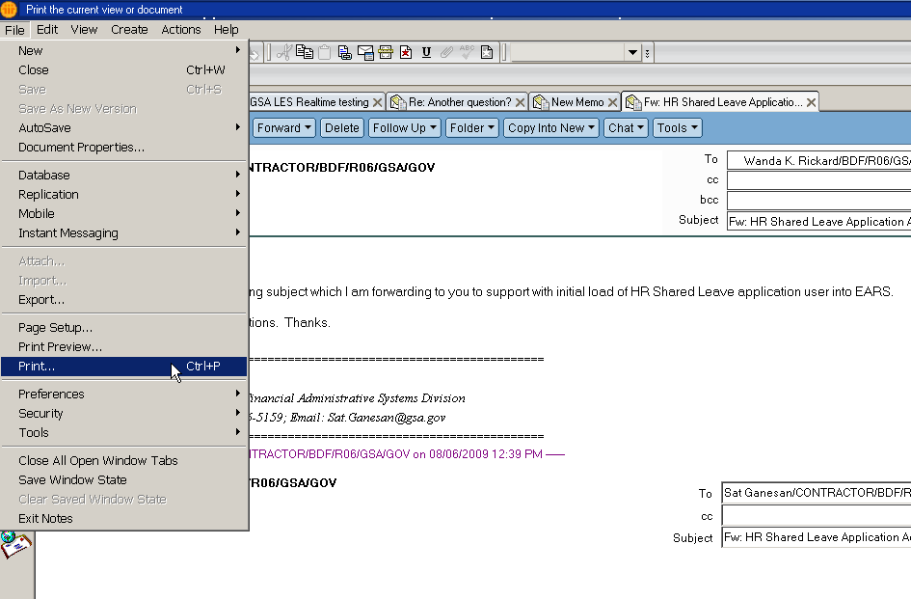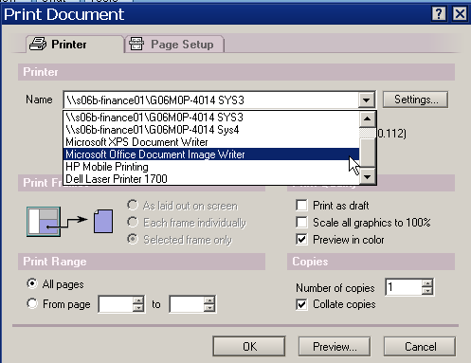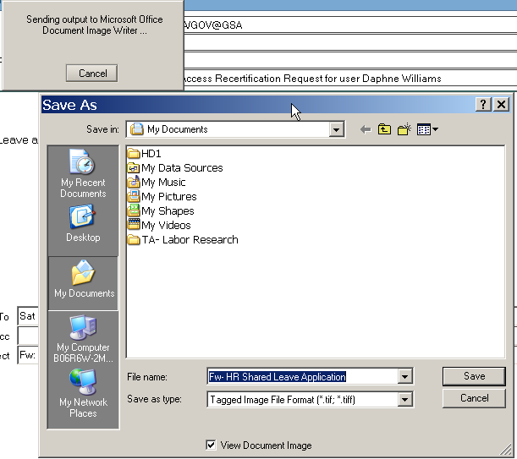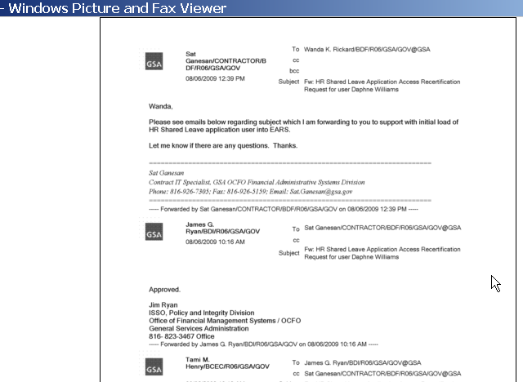Type in the file location where you want to save the document and file name you want to save it as (i.e. FEDPay_JaneDoe_092109)

- Using ENT login credentials, the Liaison will Log into ESC to create a NEW Access Request on behalf of the External Users via the ESC link - http://esc.finance.gsa.gov/cqweb/login
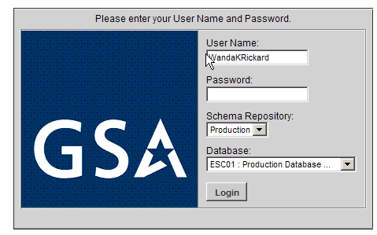
- Click on the New Change_Proposal down arrow, Scroll down and Highlight OCFOUser and click Create.
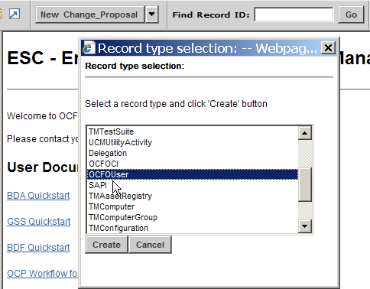
A NEW OCFOUser screen is displayed
  - Main Tab
    - Enter Email and Name(s) in the Non-ESC fields
    - Select the Liaison from the Manager/COTR (Existing) drop down menu
  - Details/Certifications
    - Enter all applicable information. At the minimum add the Agency, Phone Number, Initial Background(required), and GSA Rules of Behavior (required)
  - Click Save
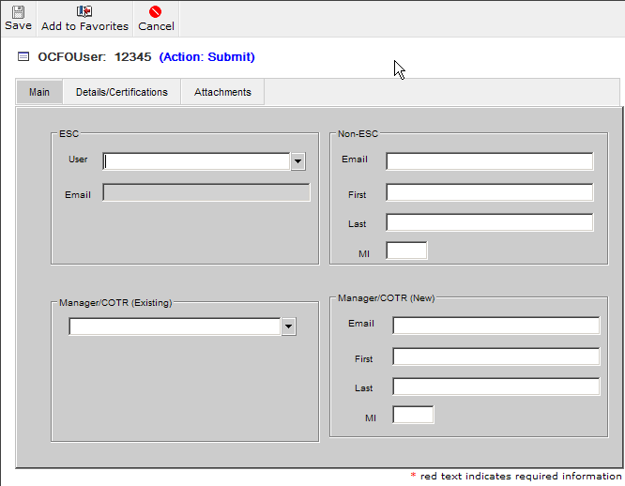

- Click on the New Change_Proposal down arrow, Highlight Access_Request and click Create.
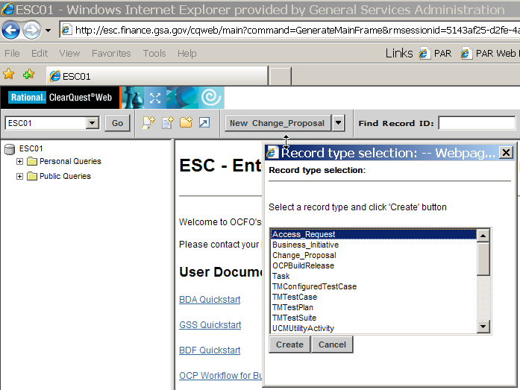

A NEW blank Access Request is displayed
  - Main Tab
    - Access for – Click the drop down menu to select User.
    - System/Subsys – Click the drop down menu to make selection
    - Access Role – Click the drop down menu to make selection. Additional roles require a new access request for each role. (repeat steps in 16.8.1.1 – 16.8.1.5)
    - Reason – Click on drop down menu to make selection.
    - If Temporary Account, check box and then enter the temporary account expiration date.
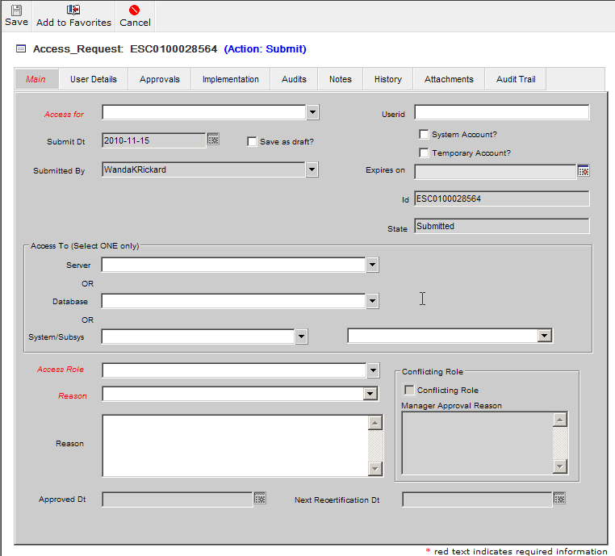
  - Attachments Tab
    - Click on Add Attachments, then Browse, locate the Manager Approval email that you saved and click Open, then Click OK. This will place the file in the Attachments body, however it will show a file size of 0 until you Save the Record. If requesting additional roles, you will need to place the approval email in each access request.
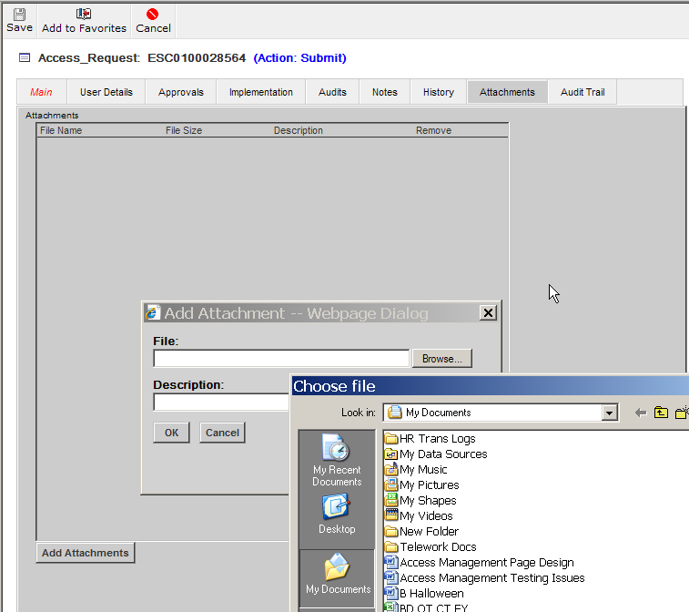
  - Click Save
- Once the access request has been saved, it will trigger the workflow process in ESC and allow the approval process to be completed via EARS. Refer to Section 5 for details of approving access requests in EARS.

