Information System Security Officer (ISSO) Approval
- The ISSO will receive an email from the System Owner to approve the request. A link in the body of the email will direct the ISSO to the corresponding Access Request.
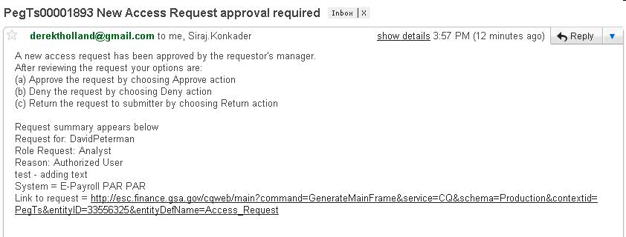
- The ISSO will sign into EARS using their ENT login credentials via https://ears.ocfo.gsa.gov/ears/faces/home.jsp.
- Once logged in, the ISSO will click the Access Management menu tab to perform the ISSO approval duties. The access request queue will display all requests that require your action. If more than 10 records exists, you can use the arrow keys to maneuver between pages
- Click on the access request (will highlight the request displayed) to populate the access request to allow approval duties.
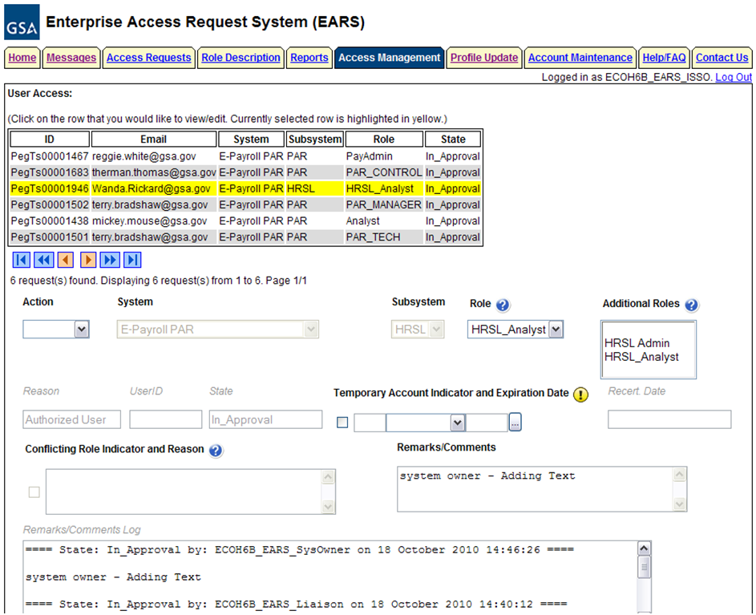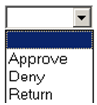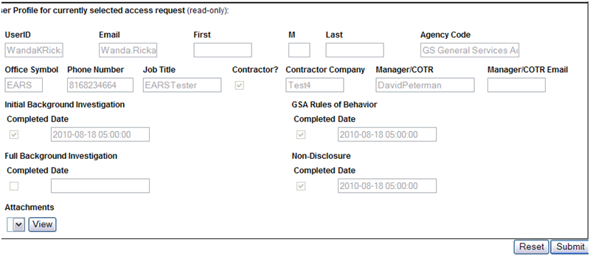

- User Access Section (* denotes Required field) – Fields that are grayed out are unavailable. The fields listed below are the ONLY fields that are to be processed by the ‘ISSO’.
  - Action* - The ISSO can Approve, Return, or Deny by clicking the down arrow Action button and choosing the appropriate action.
    - Approve action will forward the access request to the Implementation Group.
    - Return action will return the access request to the User (requestor); comments are required.
    - Deny action will cancel the access request; comments are required.
  - Remarks/Comments – This allows the ISSO to record any comments to be associated with the access request.
  - Remarks/Comments Log – Displays the entire data flow of the request with detailed information, including text from Remarks/Comments text box, associated with this access request as well as the historical approval details.
- User Profile Section – The ISSO is NOT allowed to make updates to this section.
- Reset Button – Clears the screen and allows for reentry
- Submit Button – Click the Submit button to forward the access request to the implementation group to set up the account/database access.
  - Upon clicking the Submit button a Confirmation Statement will appear.
  - The ISSO must “… certify the accuracy of the above information and need for the access as requested into the Systems listed to perform his/her job.” By clicking OK before the access will be submitted.
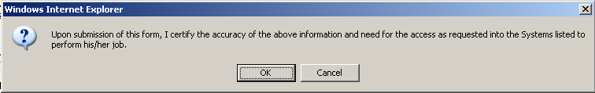

- The ISSO approving/submitting the access request does not grant immediate access; it simply verifies the approval request has been transmitted from EARS into the ESC system and will be forwarded to the next level in the workflow process (see section 15 for workflow process)
  - The access request screen will clear and display the results of the access request submission, in the lower left corner of the access request.

  - Also verify the access is removed from the access request queue.
- If multiple access requests require your approval, repeat steps 8.4 thru 8.9.
- If no further action is required by the ISSO, select Logout, located in the upper right hand corner of the screen.

