Liaison Approval
- The Liaison will be responsible for approval to the System/Subsystem and Role(s) Assignment for External System GSA users and External Client Non-GSA users. Refer to the table below for explanation of Internal/External GSA users and External Client users and the person responsible for role assignment
User Type | User Type Definition | Approval of System/Application | User to perform Role Assignment
Internal System User (GSA user) | 1. User is a GSA employee. 2. Manager selected in Access Request is listed in the ESC Manager’s table for corresponding System/Application approval path. | 1. Manager approves access to System and Subsystem.  2. Manager performs Role Assignment | Manager
External System User (GSA user) | 1. User is a GSA employee. 2. User is NOT directly associated with the System/Application office (employee is in a different organization location than the System/Application approving office) | 1. Manager approves access to System and Subsystem ONLY.  2. Leave the Role as ***TBD ***, this will flow the access request to the Liaison for approval | Liaison
External Client User (non-GSA user) | 1. User is NOT a GSA employee. | 1. Manager approves access to System and Subsystem ONLY.  2. Leave the Role as **TBD***, this will flow the access request to the Liaison for approval | Liaison

- The Liaison identified within the Manager/Liaison System/Subsystem approval group will receive an email from the sender “ESC-Do Not Reply@gsa.gov" to approve the request, as long as the Role in the Access Request is identified as ***TBD***. A link will direct the Liaison to the corresponding Access Request once logged into EARS.

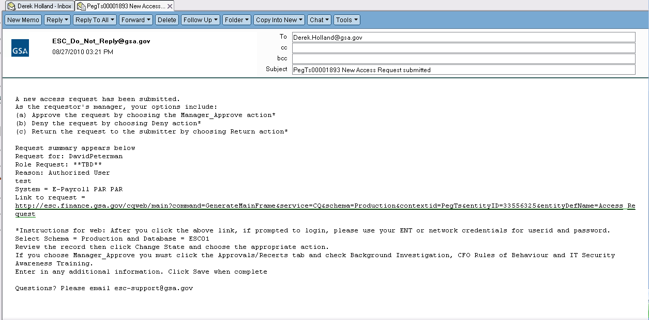
- The Liaison will sign into EARS using their ENT login credentials via https://ears.ocfo.gsa.gov/ears/faces/home.jsp.. Refer to the EARS User Guide (EARS Web Page Login), located in the Help/FAQ menu tab, for assistance with the login screen
- Once logged in, the Liaison will click the Access Management menu tab to perform their duties. The access request queue will display all requests that require your action. If more than 10 records exist, the arrow keys will maneuver between pages.
- Click on the access request you wish to process, this will display the access request and highlight the populated request in the request queue.
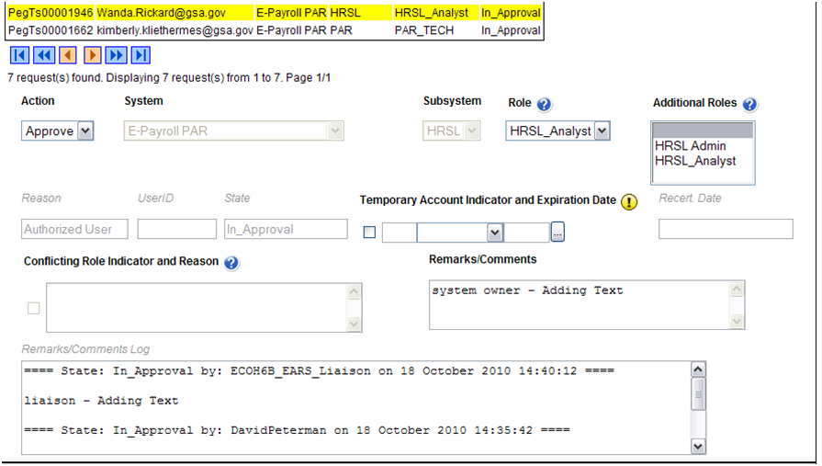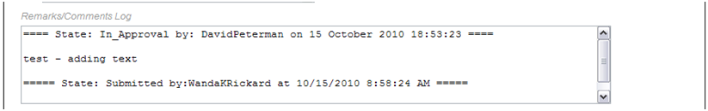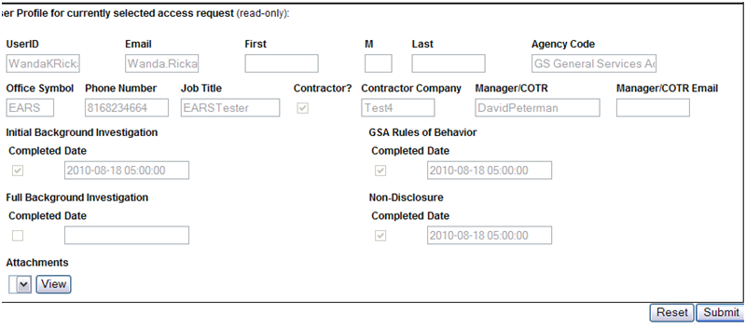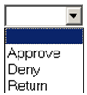

- User Access Section (* denotes Required field) – Fields that are grayed out are unavailable. The fields listed below are the ONLY field that are to be processed by the ‘Liaison’
  - Action* - The Manager can Approve, Return, or Deny by clicking the down arrow Action button and choosing the appropriate action.
    - Approve action will forward the access request to the System Owner.
    - Return action will return the access request to the User (requestor); comments are required.
    - Deny action will cancel the access request; comments are required.
  - Role / Additional Roles Assignment* – The role description document can be found under the Role Description Menu tab. Select the required Role, to select Additional Roles, hold down the Ctrl key while clicking on the additional roles.

  - Temporary Account Indicator and Expiration Date – Used to identify an access request (all roles selected) as a temporary account. If checked, an Expiration Date is required. If populated, the system will automatically deactivate the record on the requested date; no notification will be sent to the user or manager.
  - Remarks/Comments – This allows the Liaison to record any comments to be associated with the access request.
  - Remarks/Comments Log – Displays all data recorded in the Remarks/Comments text box associated with this access request as well as historical approval details.
- User Profile Section – The Liaison is NOT allowed to make updates to this section.
- Reset Button – Clears the screen and allows for reentry
- Submit Button – Click the Submit button to forward the access request to the next approver.
  - Upon clicking the Submit button a Confirmation Statement will appear.
  - The Liaison must “… certify the accuracy of the above information and need for the access as requested into the Systems listed to perform his/her job.” by clicking OK before the access will be submitted.
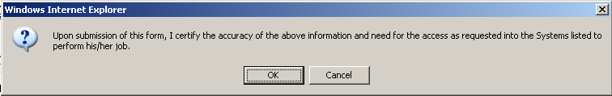
- The Liaison approving/submitting the access request does not grant immediate access; it simply verifies the approval request has been transmitted from EARS into the ESC system and will be forwarded to the next level in the approval workflow process (see section 15 for workflow process).
  - The access request screen will clear and display the results of the access request submission, in the lower left corner of the access request.
  - The access request screen will remove this request from the access request queue.
- If multiple access requests require your approval, repeat steps 6.5 thru 6.10.
- If no further action is required by the Liaison, select Logout, located in the upper right hand corner of the screen.

