EARS Web Page Login
- EARS Web Page is hosted on the public internet, but requires user login to provide an additional layer of security.
- The EARS application is by accessed by opening up a web browser and pointing it to the website address: https://ears.ocfo.gsa.gov/ears/faces/home.jsp. Upon visiting this website address a Warning Banner is presented to the user. Click OK to proceed. This allows user access to the Home, Help/FAQ, and Contact Us pages only. To submit an access request and/or perform the approval processes, the user must Login.

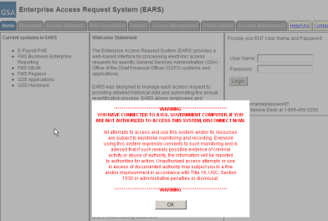
- The User’s IP address will determine if the web page requires ENT or GSA Network (EXT) account credentials to Login.
  - GSA Users will use their ENT login credentials
  - External Users (Non-GSA Users) will use their GSA Network (EXT) account login credentials
  - If the External User does not not have an EXT account, see the interim Special Processing for External (Non-GSA) Users workaround in section 16.
- Upon successful login, the account logged in will display in the upper right corner.
- The menu tabs are available based upon user login credentials as specified below, some menu tabs are currently under construction (identified in section 14).
  - User – Home, Messages, Access Requests, Profile Update, Help/FAQ, and Contact Us
  - Manager/Liaison/System Owner/ISSO – Home, Messages, Access Requests, Role Description, Access Management, Profile Update, Help FAQ, and Contact Us
