Access or Recertification Requests - Manager Approval
V1.1 7-8-11

Manager approval is a simple process that is required by security regulations for each role a user has in an application. Any new access cannot be implemented without your approval. Additionally, if you fail to approve recertification requests, in a timely manner, for a role that a member of your staff is using, their access will be cancelled and they will have to re-apply for access.
Normally, managers are notified by email when they have a new access request or re-certifications for their staff, but this is not always the case. A manager can check at any time to see if there are pending requests that need to be processed.

An example of no notification is when a staff member submits a request under an incorrect manager and then changes their User Profile to reflect the correct manager. The correct manager will not get an email notification of the requests and must log in and go into the “Access Management” tab to process the new requests.

Overview - Manager Approval for New Access or Recertification
- Sign into EARS
- Proceed to “Access Management” tab for list of any approvals that you need to do (there may be none if you have received no emails to do so)
- Highlight the request you want to process.
- Choose the appropriate “Action” from the pulldown list (See details below)
- Click “Submit” button to process the request.
- Repeat for each requests in your list.
That’s All you need to do !!

Detail – Manager Approval

- The Manager identified within the Access or Recertification Request will receive an email from the sender “ESC-Do Not Reply@gsa.gov" (see example below) to approve the request. A link will direct the selected Manager to the corresponding Access Request, once logged into EARS. As mentioned earlier, it is NOT necessary to have an email to initiate request approvals in EARS.

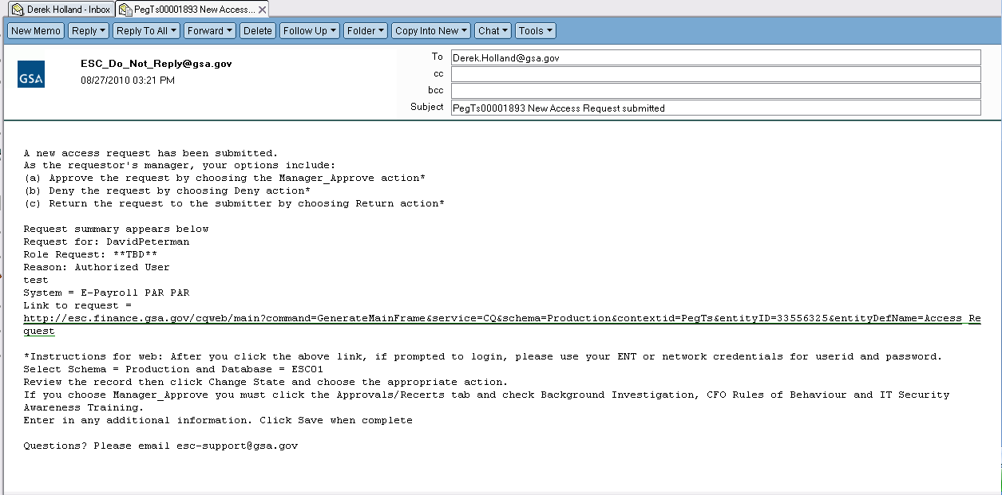
- The manager will sign into EARS using their ENT or GSA network (EXT) login credentials via https://ears.ocfo.gsa.gov/ears/faces/home.jsp. Refer to the EARS User Guide (EARS Web Page Login), located in the Help/FAQ menu tab, for assistance with the login screen.
- Once logged in, the Manager will click the Access Management menu tab to perform the manager approval duties. (See Below) The access request queue will display all requests that require your action. If more than 10 records exist, the arrow keys will maneuver between pages. Click on the access request you wish to approve, this will display the access request and highlight the populated request in the request queue.
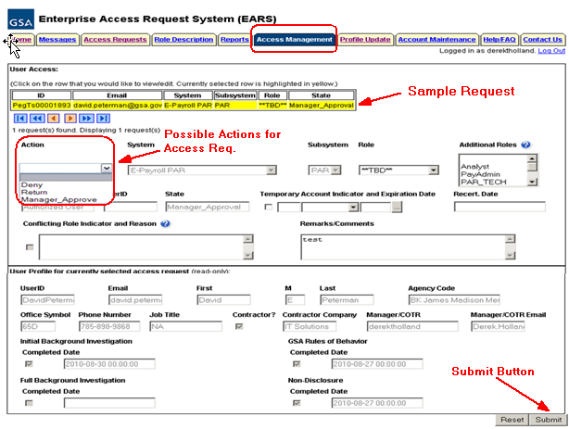Access Request Screen-Shot
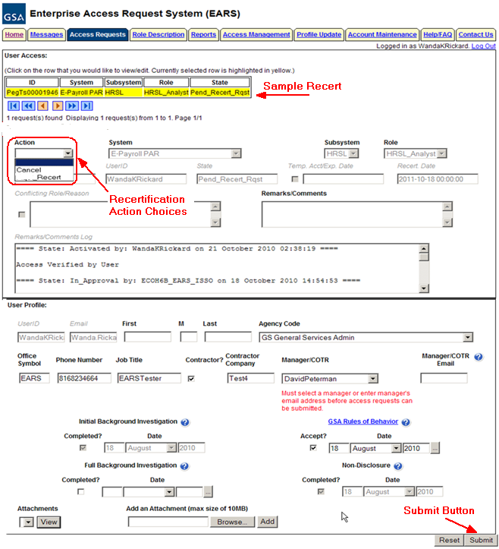Recertification Request Screen-shot

- User Access Section (* denotes Required field) – Fields that are grayed out are unavailable. The fields listed below are the ONLY fields that are to be processed by the ‘Manager’
  - Actions* - There are different actions depending on whether they are for Access Requests or Recertification Requests. See the details Below.
    - Access Actions The Manager can Approve (Manager_Approve), Return, or Deny by clicking the down arrow Action button and choosing the appropriate action.
      - Manager_Approve action will forward the access request to the System Owner (for Internal System GSA users) as long as a Role is assigned. If a role is not assigned (ex Role **TBD**) , it will forward that access request to the Liaison or System Owner.
      - Manager_Approve action will forward the access request to the Liaison (for External System GSA users and External Client users) as long as the role has not been assigned (ex Role **TBD**).
      - Return action will return the access request to the User (requestor); comments are required.
      - Deny action will cancel the access request; comments are required.
    - Recertification Actions –
      - Recertify – Approve the request from the user to continue in this role in this application
      - Cancel – Do not approve the request from the user to continue in this role in this application
      - Check-Recert – DO NOT USE
  - Role / Additional Roles Assignment* (if applicable-not normally used) – The role description document can be found under the Role Description Menu tab. To select Additional Roles, hold down the Ctrl key while clicking on the additional roles. Refer to the table below for explanation of Internal/External GSA users and External Client users and the person responsible for role assignment
User Type | User Type Definition | Approval of System/Application | User to perform Role Assignment
Internal System User (GSA user) | 1. User is a GSA employee. 2. Manager selected in Access Request is listed in the ESC Manager’s table for corresponding System/Application approval path. | 1. Manager approves access to System and Subsystem.  2. Manager performs Role Assignment | Manager
External System User (GSA user) | 1. User is a GSA employee. 2. User is NOT directly associated with the System/Application office (employee is in a different organization location than the System/Application approving office) | 1. Manager approves access to System and Subsystem ONLY.  2. Leave the Role as ***TBD ***, this will flow the access request to the Liaison for approval | Liaison
External Client User (non-GSA user) | 1. User is NOT a GSA employee. | 1. Manager approves access to System and Subsystem ONLY.  2. Leave the Role as **TBD***, this will flow the access request to the Liaison for approval | Liaison

    - Internal System User - The Manager is expected to perform the role(s) assignment.
    - External System and External Client User - The Manager is expected to leave the role as ***TBD***; this operation will be performed by the Liaison.

  - Temporary Account Indicator and Expiration Date – Used to identify an access request (all roles selected) as a temporary account. If checked, an Expiration Date is required. If populated, the system will automatically deactivate the record on the requested date; no notification will be sent to the user or manager.
  - Remarks/Comments – This allows the Manager to record any comments to be associated with the access request.
  - Remarks/Comments Log – Displays all data recorded in the Remarks/Comments text box associated with this access request as well as historical approval details.
- User Profile Section – The Manager is NOT allowed to make any updates to this section.
- Reset Button – Clears the screen and allows for reentry
- Submit Button – Click the Submit button to forward the access request to the next approver.
  - Upon clicking the Submit button a Confirmation Statement will appear.
  - The Manager must “… certify the accuracy of the above information and need for the access as requested into the Systems listed to perform his/her job.” by clicking OK before the access will be submitted. This will submit and apply the Manager approval to ALL roles selected.
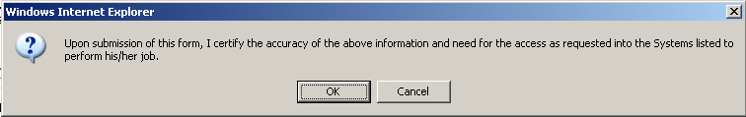
- The Manager approving/submitting the access request does not grant immediate access; it simply verifies the approval request has been transmitted from EARS into the ESC system and will be forwarded to the next level in the approval workflow process.
  - The access request screen will clear and display the results of the access request submission, in the upper or lower left corner of the access request screen.
  - The access request screen will remove this request from the access request queue.
- If multiple access requests require your approval, repeat steps 3 thru 7 as appropriate for the request involved..
- If no further action is required by the Manager, select Logout, located in the upper right hand corner of the screen.

