System Owner Approval
- The System Owner will receive an email from the Manager to approve request A link in the body of the email will direct the System Owner to the corresponding Access Request.
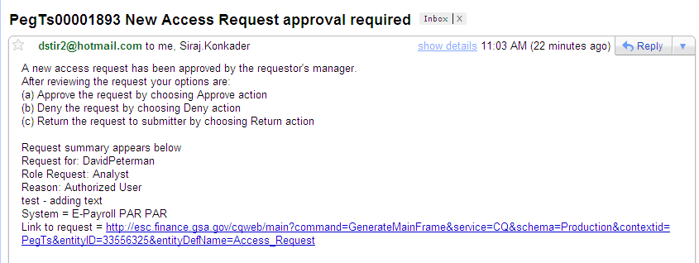
- The System Owner will sign into EARS using their ENT login credentials via https://ears.ocfo.gsa.gov/ears/faces/home.jsp. Refer to the EARS User Guide (EARS Web Page Login), located in the Help/FAQ menu tab, for assistance with the login screen.
- Once logged in, the System Owner will click the Access Management menu tab to perform the System Owner approval duties. The access request queue will display all requests that require your action. If more than 10 records exists, you can use the arrow keys to maneuver between pages
- Click on the access request you wish to approve; doing this will display the access request and highlight the populated request in the request queue.
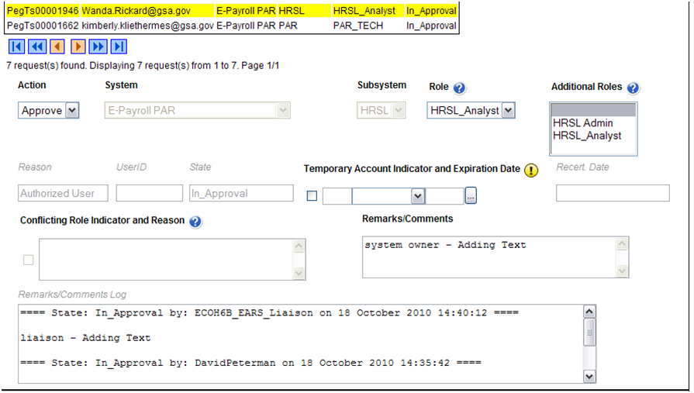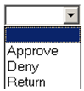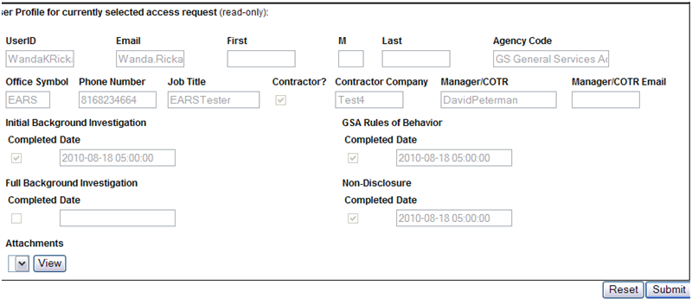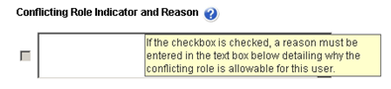

- User Access Section (* denotes Required field) – Fields that are grayed out are unavailable. The fields listed below are the ONLY fields that are to be processed by the ‘System Owner’.
  - Action* - The System Owner can Approve, Return, or Deny by clicking the down arrow Action button and choosing the appropriate action.
    - Approve action will forward the access request to the Information System Security Office (ISSO).
    - Return action will return the access request to the User (requestor); comments are required.
    - Deny action will cancel the access request; comments are required.
  - Role / Additional Roles Assignment – This field will be populated with the role assigned by the Manager or Liaison. If unsure of the role assigned, you can review the roles under the Role Description Menu tab. The System Owner can assign Additional Roles if desired.
  - Temporary Account Indicator and Expiration Date – Used to identify an access request (all roles selected) as a temporary account. If checked, an Expiration Date is required. If populated, the system will automatically deactivate the record on the requested date; no notification will be sent to the user or manager.
  - Conflicting Role Indicator and Reason - If this field is checked, a reason must be entered in the text box field detailing why the conflicting roles is allowable for the identified user. The conflicting roles identified within the role description document are set up in ESC upon the initial data load of the System/Application.

  - Remarks/Comments – This allows the System Owner to record any comments to be associated with the access request.
  - Remarks/Comments Log – Displays the entire data flow of the request with detailed information, including text from Remarks/Comments text box, associated with this access request as well as the historical approval details.
- User Profile Section – The System Owner is NOT allowed to make updates to this section.
- Reset Button – Clears the screen and allows for reentry
- Submit Button – Click the Submit button to forward the access request to the next approver.
  - Upon clicking the Submit button a Confirmation Statement will appear.
  - The System Owner must “… certify the accuracy of the above information and need for the access as requested into the Systems listed to perform his/her job.” By clicking OK before the access will be submitted.
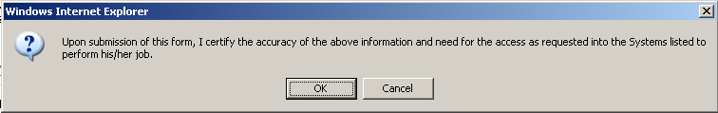
- The System Owner approving/submitting the access request does not grant immediate access; it simply verifies the approval request has been transmitted from EARS into the ESC system and will be forwarded to the next level in the approval workflow process (see section 15 for workflow process)
  - The access request screen will clear and display the results of the access request submission, in the lower left corner of the access request.

  - Also verify the access is removed from the access request queue.
- If multiple access requests require your approval, repeat steps 7.4 thru 7.9.
- If no further action is required by the System Owner, select Logout, located in the upper right hand corner of the screen.

